


Emergency Nutrition Assessment (ENA) software:
A practical user’s guide

A SMART survey is designed to be analyzed by computer using the ENA software. It can be downloaded free from either www.smartindicators.org or from www.nutrisurvey.de/ena/ena.html

The steps for using ENA are as follows:

1. Planning the survey.
2. Training the teams.
3. Entering the nutritional (anthropometric and oedema) data.
4. Entering the mortality data.
5. Checking the data for errors and plausibility.
a. Highlighting implausible values.
b. Analysis for digit preference.
c. Analysis by team.
d. Comparison of the prevalence of severe malnutrition calculated from the mean and standard deviation with the prevalence from counting the subjects below the cut-off points.
6. Generating the results.
7. Writing the report using a standard format.

N.B. Before beginning this tutorial, import the dummy dataset provided with ENA. To do so, click the ‘open survey’ button on the ‘Data Entry Anthropometry’ tab, select the ‘anthro’ file and click ‘OK’.

- Planning the survey

Figure 1 shows the ENA survey planning screen.

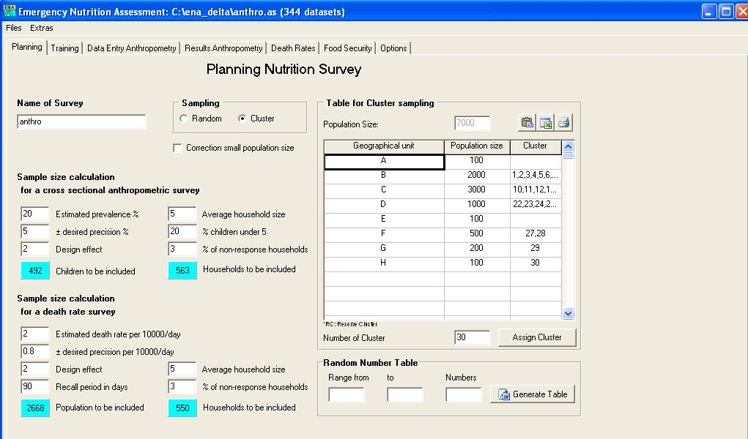
Name of survey
Start by giving the survey must be given a unique name. The dummy dataset has been named ‘anthro’.

Sampling
There are two options for sampling when conducting nutrition &/or mortality surveys. For a variety of reasons, ‘Random’ sampling is preferable to ‘Cluster’ sampling, but in most cases, random sampling is not possible due to logistic or time constraints. Therefore, cluster sampling is more often chosen as a sampling strategy. However, outcomes are often clustered in villages or households, and this clustering effect needs to be taken into consideration when calculating the precision of the estimates of prevalences and rates. The result is that a cluster sampling design requires a larger sample size for a given precision than random sampling design.

Sample size calculation for a cross sectional anthropometric survey

Estimated prevalence - If you are uncertain, enter the highest (maximum) prevalence you expect from a range of likely values. However, if you are interested in a particular prevalence (for example, the level that would trigger an emergency response), and you suspect the actual prevalence is below this threshold, enter the threshold number.

Precision - Enter the widest confidence interval you can tolerate in the estimate (normally 5% or more at high rates of prevalence, falling to about 2.5% for lower rates). This figure has a substantial effect upon the number needed for the sample.

Design effect - The default design effect for sample size calculations for malnutrition is 2.0. However, a design effect of 1.5 for malnutrition in children is often sufficient. The decision should be made individually for each emergency context.

The result of these steps is to yield the total number of children required (sample size). This figure will be automatically calculated and will appear in the ‘Children to be included’ blue box.

In addition, the number of households to be included can be calculated for planning purposes, but filling the ‘Average household size’, ‘% children under 5’ and ‘% of non-response households’ boxes. These can be estimated using previous survey data or by approximations.

In cluster surveys, this number should be divided by the number of households that can be visited each day. This will provide the number of clusters.

Mortality
Estimates death rate…
For the mortality component of the survey:
2. Enter the expected mortality rate (/10,000 persons/day).
3. Enter the required precision (/10,000 persons/day). For example, if your
expected mortality rate is 2.0/10,000 persons/day and you want a confidence
interval of 1.4–2.6, enter a required precision of 0.6 (i.e., 2.0 ± 0.6 = 1.4–2.6).
The precision chosen has a substantial effect upon the sample size needed.
4. Enter the design effect. The default design effect for sample size calculations
for mortality is 2.0. If violence-related-mortality is limited, a design effect of
1.5 for crude death rate may also be sufficient.
5. Enter the chosen recall period in days. In most situations, a recall period of
approximately 90 days (or between 30 to 120) days will be used. However,
the decision should be made individually for each emergency context. This
will depend upon the time of a “memorable event,” and this is rarely exactly
90 days. The recall period also has a substantial effect upon the number of
households that will need to be interviewed.

average household size.
NON6RESPONSE BIAS

5.1.1 Choosing the clusters
5.1.1.1 Enter the number of clusters
There should always be at least 30 clusters. Twenty-six clusters is the minimum for the
survey to be valid. The best way to obtain the number of clusters is to decide realistically
the number of households that can be visited in one day. The higher of the two values, (a)
the total sample size of children (assuming an average of one eligible child per household
visited), or (b) the total households needed for the mortality survey, is divided by the
number of households that can be visited in one day. This is the number of clusters that
should be chosen if it is equal to or more than 30. Otherwise, 30 clusters should be used.
If there is a choice, it is better to increase the number of clusters and reduce the numbers
of children in each cluster.

5.1.1.2 Choose the clusters
Enter the names of all the villages, towns, subdistricts, or other areas that will potentially
be chosen to include in a cluster. All potential areas have to be entered. It does not matter
what order the areas are entered. If they are omitted at this step, they are not part of the
surveyed population.
Enter the estimated population size for each “village.”
The computer will then select the areas where there will be clusters. This is calculated at
random, with the chance of any village being chosen being proportional to its population.
This should be done only once. Once the cluster sites have been chosen, this is fixed. It
will potentially introduce a bias if they are reselected. Under no circumstances should the
program be rerun several times until particular villages are included or excluded.

RANDOM NUMBER TABLE??

5.1.2 Field recording
The anthropometric data are entered on datasheets as they are taken (Annexes). These
sheets are included in the software in Microsoft Word format for printing. One data sheet
is used for each cluster.
In most surveys it is not necessary to enter the child’s name if the child is at home and the
measurements are complete. This only takes additional time for the team to record and
the data are not used. Names are entered for eligible children who are absent from the
house when it is visited. This enables the team to ask for the specific child when they
return to the house at the end of the day. A household number has to be assigned to each
house even if it has no eligible children. They are recorded at the end of the sheet and
given consecutive household numbers starting with 31 and recorded as having no
children. The same household number is used for the mortality data form. The WHM (%
WFH) is not calculated for each child on the datasheet in the field. The reason for having
this column is for children who are going to be referred to a feeding center or other
facility. The last columns are used for notes or other data that are to be collected for each
child (e.g., MUAC).

5.1.3 Data entry
The data is entered into the computer using the ENA software. The entry panel is
shown below.

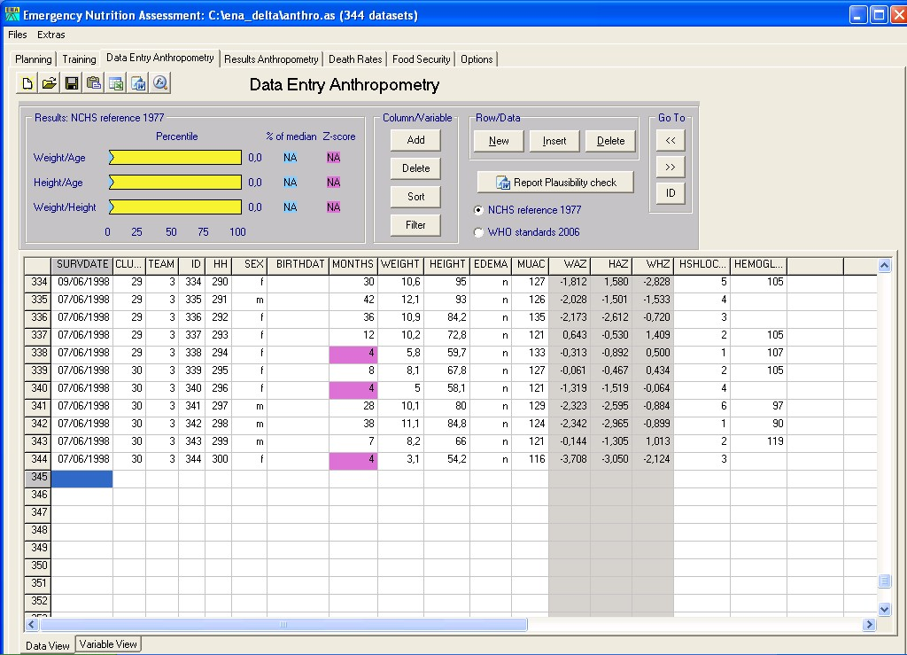

The survey date, cluster number and team number are entered in the first row (the village
that has been chosen for the cluster is already in the database in the planning stage—the
same cluster number should be used in this panel). As the data are entered these fields
will default to the last entered information so that the data do not have to be entered for
each subject.
The identification number will increment automatically by one for each new record that
is entered.
The household number will not be incremented, as there is often more than one child in
the same house. The household number needs to be entered. These must be the same
household numbers as those used for entering mortality data.
Enter either the age in months or the birth date in the age fields. If the birth date is
entered, the age is automatically calculated. If age is entered the birth date field is left
blank. It is not necessary to enter an age to proceed. If age is not entered, it is assumed
the child was selected on the basis of height and that the age is not known with sufficient
accuracy to be recorded. In this case, WFA and HFA will not be calculated or entered
into the database.
The anthropometric variables are automatically calculated as data are entered. If there
appears to be an error in the data, the field will turn red. The cutoff points to alert the
person entering the data can be set in the options screen (See Options).

The program will list and query any value that is ± three standard deviations of the survey mean. After one or two clusters have been entered, or if there has been a previous survey, it is useful to enter in the variable view sheet the limits as the mean ± three standard deviations (or 3 z-scores) during data entry. This enables potential errors to be picked up as early as possible during data entry.

Plausibility report – interpretation…

It is useful to enter the data into the computer when the team gets back to base, or even in
the field using sub-notebooks with long battery life if these are available (software for
Pocket PCs that is directly linked to Nutrisurvey is currently under development). This
will facilitate a return to the household (while the team is still in the area) to retake the
measurements.
If the edema field is not entered, it defaults to edema being absent during analysis.
5.1.4 Naming of files
It is important to be consistent in naming files and directories and to give all files names
that can be recognized later by any member of the team. All the files relating to a
particular survey should be put into a separate directory.
The name of the file should start with a three letter code for the country (e.g., SUD for
Sudan, ZAM for Zambia, ANG for Angola, etc.), then the file-name should have the date
of the survey in YYMM format (year, year, month, month). In certain circumstances the
region, type of subject (refugee, IDP, resident), or the agency involved can be usefully
included in the name of all the files. Then there is a code for the type of file: REP for
report, DAT for the data file, etc.
Figure 12. The Nutrisurvey entry interface
85
This naming convention means that if the files in the directory are sorted they will
automatically be listed in a clear order and all the files pertaining to a particular survey
will be together. All files related to one survey should be kept in a unique directory. The
directory should also be named using the same convention (by country and date), and any
other information that makes the directory unique for a particular survey. It is important
that everyone in an agency uses the standard convention for naming files.
Thus, a file named <LIB_0408_rep.doc> would be the report of a survey taken in August
2004 in Liberia. There may be several simultaneous surveys conducted in Liberia around
that time, <LIB_0409_IDP_Buchanan_AAH_dat.xls> would be the data file for a survey
with IDPs in Buchanan, Liberia in September 2004 conducted by Action Against Hunger.
Under no circumstances should the files be called “report.doc” or
“SupervisorsName.doc.”
5.1.5 Data preparation and cleaning
Before doing the definitive analysis, any errors in the data need to be identified and, if
possible, corrected. This is done partly during data entry. An implausible or “out-ofrange”
value is colored red during data entry. The ranges should be set in the variable
view sheet before data entry.
Data cleaning is also done using Nutrisurvey’s “plausibility” check. The computer
automatically examines the data to see if there are values outside the usual or expected
range and lists them in Microsoft Word. These values should be reviewed and checked
against the original written data collection sheets. Any error in data entry should be
corrected immediately.
5.1.5.1 Missing data
If certain critical pieces of information are missing from a child’s survey record, it will
not be possible to include the child in some of the anthropometric data analyses:
Age: If information on age is missing, you can still include the child in the assessment of
wasting and edema, because these do not require age. However, you will need to be sure
the child is eligible to be in the survey (i.e., in the required height range of 65cm–110cm).
Sex: If information on sex is missing you should still include the child in the assessment
of wasting and edema. The reference population information on height and weight is sex
specific. However, the difference between the sexes in terms of the WFH reference
standards is small, and irrelevant for edema.
Height: If information on height is missing you cannot include the child in the
assessment of wasting. However, the child can still be included in an analysis of edema,
because any child with edema is severely malnourished.
Weight: If information on weight is missing you cannot include the child in the
assessment of wasting. However, the child can still be included in an analysis of edema.
5.1.5.2 Data outside the required range
In most nutrition surveys, we are measuring children aged 6–59 months, or children who
are 65cm–110cm tall. Children outside these ranges should not be included in the results.
These values depend upon the defaults that have been set in the variable view sheet of the
86
software. The default is to accept any child who is in the correct age range, even if the
height is out of range. Any child outside the age range will be marked by the program. If
height data are missing, the anthropometric indices of interest cannot be calculated.
However, if the age is within range, the child can be included if there is edema. The
accepted height range can be altered in the variable view sheet, for example, to change
the range to 60cm–100cm if the population is very stunted. These choices must be
included in the report.
Thus, by default, if a child is 55 months old and 112cm the child will be included.
However, if the child is 65 months old, it should not be included and the computer will
automatically exclude the child in the results.
5.1.5.3 Extreme WFH data
In addition to excluding children with missing information, or who are out of the required
range, we also want to exclude children who have a WFH that is more likely to be the
result of an error than a true measurement. There are various ways of doing this. Clearly,
data that are biologically unlikely are very likely to be the result of a measurement or
recording error. Thus, it is very unusual in an emergency context to find any child with a
WHZ < –5.00 or a WHZ > +3.00.
Most children with wrongly measured data give values that are within the plausible
range. Inclusion of such errors can be surmised from examination of the standard
deviation, and other statistical checks on the data. The standard deviation should be
between 0.8 and 1.2 z-score units for WFH in all well-conducted surveys (in 80% of
surveys the standard deviation is between 0.9 and 1.1 z-score units). The standard
deviation increases as the proportion of erroneous results in the dataset increases; this has
a very dramatic effect upon the computed prevalence of wasting. For this reason, if a
value is more likely to be an error than a real measurement, it should be removed from
the analysis. We do this by taking the mean of the WFH data as the fixed point for
describing the status of the population we are surveying. Statistically about 2.5 children
out of 900 will lie outside the limits of ±3 z-score units of the mean. Less than 0.5 out of
1,000 will lie outside ±3.5 z-score units from the mean. This forms the basis for deciding
if a value is more likely to be an error than a real measurement. The software will list
children with these extreme values in the plausibility check list.
5.1.5.4 Checking for measurement bias
Measurement bias occurs when the team has not been adequately trained or supervised or
when the measuring equipment is faulty. The best way to avoid measurement bias is to be
rigorous in training and supervision and put in place careful checks to assure the quality
of the equipment. Supervisors should check data collection forms at the end of each day
to see if WHZ are feasible and within the plausibility range, and to see if edema is being
realistically reported.
There are several useful methods to check the quality of the anthropometric data
collected during a nutrition assessment after the data has been collected:
First, the distribution of the final decimal for height and weight. This will tell you if the
team members are rounding weights and height to the nearest kilogram or centimeter,
respectively. This phenomenon is called “digit preference.” Nutrisurvey automatically
87
examines the data for digit preference. Furthermore, it examines the digit preference for
each of the teams. There may be one team that is “cutting corners” or has been
improperly trained or supervised. The data can then be examined to see if there is a
substantial difference if the data from that team is omitted.
Second, the standard deviation of the z-scores for WFH and HFA should be examined.
As explained in the section on extreme values, this tells you if there is substantial random
error in the measurements. If the standard deviation is high (over 1.2), it is likely that
there are a lot of extreme values and values more than ±3 z-scores of the mean.
Nutrisurvey not only examines the standard deviation for the whole survey, but it also
calculates the standard deviation for each team’s measurements and the number of
extreme values for each team. The standard deviation and prevalence of malnutrition can
then be examined omitting the data from one team. Comparison of the data with and
without that particular team’s results should be undertaken to see if there is a substantial
difference. Any problems should be reported.
There are other statistical measures that are computed on the data and for each team’s
results. First is skewness, which measures the extent to which the results are symmetrical.
The “moment of skewness” should lie between 1 and –1. Similarly, kurtosis measures
whether the tails are very long (Mexican hat) or very short (pudding shaped), with too
many values in the shoulders of the distribution. The “moment of kurtosis” should also
lie between 1 and –1. These variables can also be computed for each team, and with one
team omitted. It is extremely difficult to fabricate data for weight and height that “pass”
all these checks for data distribution. In particular, the kurtosis checks whether values
that might be considered to be an error by the team have been removed (sometimes
referred to as “overcleaning”). If any of the distribution checks are abnormal, the survey
may be biased and the results unreliable.
There is a further check that can be made with a cluster survey. If the number of
individuals with wasting in each cluster is calculated, there will be one number for each
cluster. These numbers should follow a statistical distribution called a Poisson
distribution. The program tests whether the numbers follow this distribution statistically.
If the distribution is not Poisson, it means the population forming the sample is
heterogeneous, with “pockets of malnutrition” and areas that are spared. These problems
are often caused by the design of the survey, nonrandom selection of the villages to
contain the clusters, biased selection of houses in some areas, or excessive heterogeneity
in the surveyed population. The Nutrisurvey software automatically calculates the
Poisson distribution for wasting and compares this with the expected distribution. If the
data do not follow a Poisson distribution, there will also be a larger than usual design
effect. These two statistics give complementary information.
When we examine many surveys, we find that the clusters with edema do not follow a
Poisson distribution, as they should if the whole population were equally vulnerable. In
fact, edema follows what is called a “negative binomial” distribution, which means that
there are some villages where lots of children get edema and others that are relatively
protected. This design effect for edema is usually larger than for wasting, and this
complicates calculation of the confidence intervals for severe malnutrition.
If there is no substantial digit preference, the standard deviation is between 0.8 and 1.2,
the moments of skewness and kurtosis are within the range of 1 to –1, and the distribution
of wasting follows a Poisson distribution, then one can be reasonably confident that the
88
survey has been properly conducted, the sampling method is a fair representation of the
population, and the results can be relied upon.
Even if there is no immediate intervention expected to address stunting, calculating the
HFA z-scores and their standard distribution should also be examined. The most usual
reason for a problem with the HFA data is determination of age.
Once the data have been cleaned and examined to ensure they are plausible, we proceed
to the final analysis.
5.1.6 Analysis and reporting
The graphs of the distribution of the combined variables, by gender, should be examined.
The data are automatically analyzed and reported as a Microsoft Word file. The headings
are generated. The survey supervisor should go through each heading and enter the
relevant information. The quantitative data are presented in the tables.
To put the illustrations into the report, the graphs are transferred to the clipboard within
Nutrisurvey and pasted into the report at the appropriate place.

